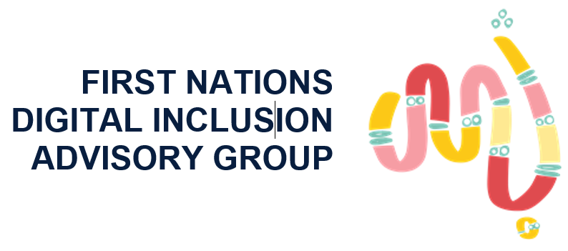

First Nations Digital Inclusion Advisory Group

Meeting 11 – communique
The First Nations Digital Inclusion Advisory Group (Advisory Group) had its 11th meeting on Thursday 2 October, 2025. The meeting was held in Meanjin (Brisbane) on the lands of the Jagera and the Turrbal peoples.
Attendees included members of the Advisory Group and Digital Inclusion Expert Panel, as well as representatives from the Department of Infrastructure, Transport, Regional Development, Communications, Sport and the Arts (the department).
The Advisory Group heard from a number of presenters, including the Department of Finance and the WA Office of Digital Government, the National Indigenous Australians Agency (NIAA), and Optus.

Update on Digital ID
Representatives from the Department of Finance and the WA Office of Digital Government provided a progress update on their trial to support people who do not have traditional ID documentation to access a Digital ID. They also invited the Advisory Group’s views on Digital ID Rules and Accreditation Rules.
The Advisory Group noted that lack of traditional ID documents continues to be a barrier to Digital ID take up by First Nations Australians, and indicated this could have a negative impact on digital inclusion in the future. The Advisory Group emphasised the importance of ensuring next steps explicitly consider the needs of communities both with and without connectivity.

Update from the Australian Government
The department provided an update on a range of work underway to support First Nations digital inclusion, as well as broader priorities in the communications portfolio, including the Universal Outdoor Mobile Obligation (UOMO) and the Government’s response to the 2024 Regional Telecommunication Review.
NIAA provided an update on the Indigenous Broadcasting and Media Program, as well as broader matters relating to First Nations media. The Advisory Group welcomed the Government’s $12 million investment in the IBMP, however, noted that there is a strong need for an increase in ongoing funding to ensure sector sustainability in the longer term.

Update from Optus
A senior representative from Optus provided an update on current events, including the outage on 18 September which impacted on Triple Zero calls in some states and territories, and the Federal Court decision on Optus’ unconscionable conduct.
They outlined the work underway within Optus to address the conduct, as well as the different elements of the enforceable undertaking with the Australian Competition and Consumer Commission (ACCC). They also thanked the Advisory Group for its feedback to date, and indicated Optus would welcome further engagement with them in the future as it seeks to rebuild trust and confidence with consumers and the Australian public.

Establishment of the First Nations Telecommunications Working Group (FNTWG)
The Advisory Group has established a First Nations Telecommunications Working Group (Working Group), which will be co-chaired by senior executives from Telstra and NBN Co. Its current membership includes Optus, BAI, TPG and Vocus, as well as the ACCC and the Australian Communications and Media Authority (ACMA).
The purpose of the Working Group is to support industry collaboration and accountability for industry-specific recommendations in the First Nations Digital Inclusion Roadmap (Roadmap). The chairs of the Working Group provided an update on outcomes from its first meeting, which was held on 26 September, and its forward workplan.

Engagement with states and territories
The Advisory Group discussed its ongoing engagement with states and territories, including a workshop with jurisdictional representatives on 1 October 2025. The workshop focused on discussing how states and territories are delivering on the recommendations in the Roadmap, as well as how to support stronger collaboration across government and with industry.
The Advisory Group noted strong support for the Roadmap’s recommendations across government, including improving connectivity in remote communities, sharing and collecting data, and supporting digital literacy and online safety.

